Food Log

Weekday (Day 1)

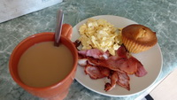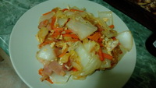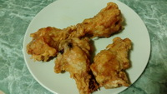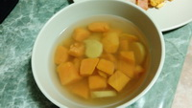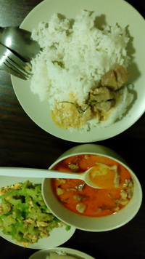

Weekday (Day 2)

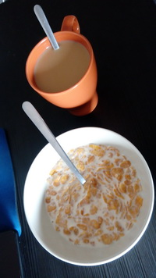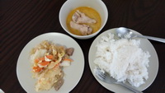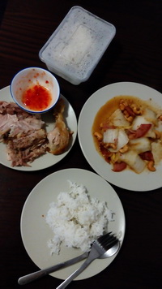

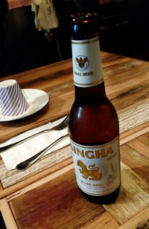Weekend (Day 1)

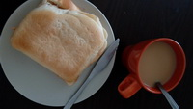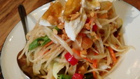

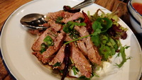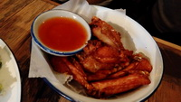

# Reflective Summary

Logging food intakes by taking photos of the meal is one efficient method to keep track of all the daily consumption. Using camera to capture the meal is fast and timeline-based while can provide details of the meal. When I browse through all my photos, I know exactly what I have eaten in chronical order.

However, this method does not provide useful figures, especially regarding the amount. Also, logging by images can become very messy over time when there are too many photos to browse through.

Besides the timeline, organizing the photos using folders structure can be more efficient over time. In terms of the amount, this method may not be a good solution if I want to visualize or compare my consumption over time.